

Sultan Qaboos University

Computer Science Department

Introduction to computer science COPM3700

**Buabat Alatta**

**Team members:**

Muhanad hamed alhabsi 140020

Hamza Muhammed alshaqsi 140609

Anas munther almanthari 141314

DonationToDB.PHP:

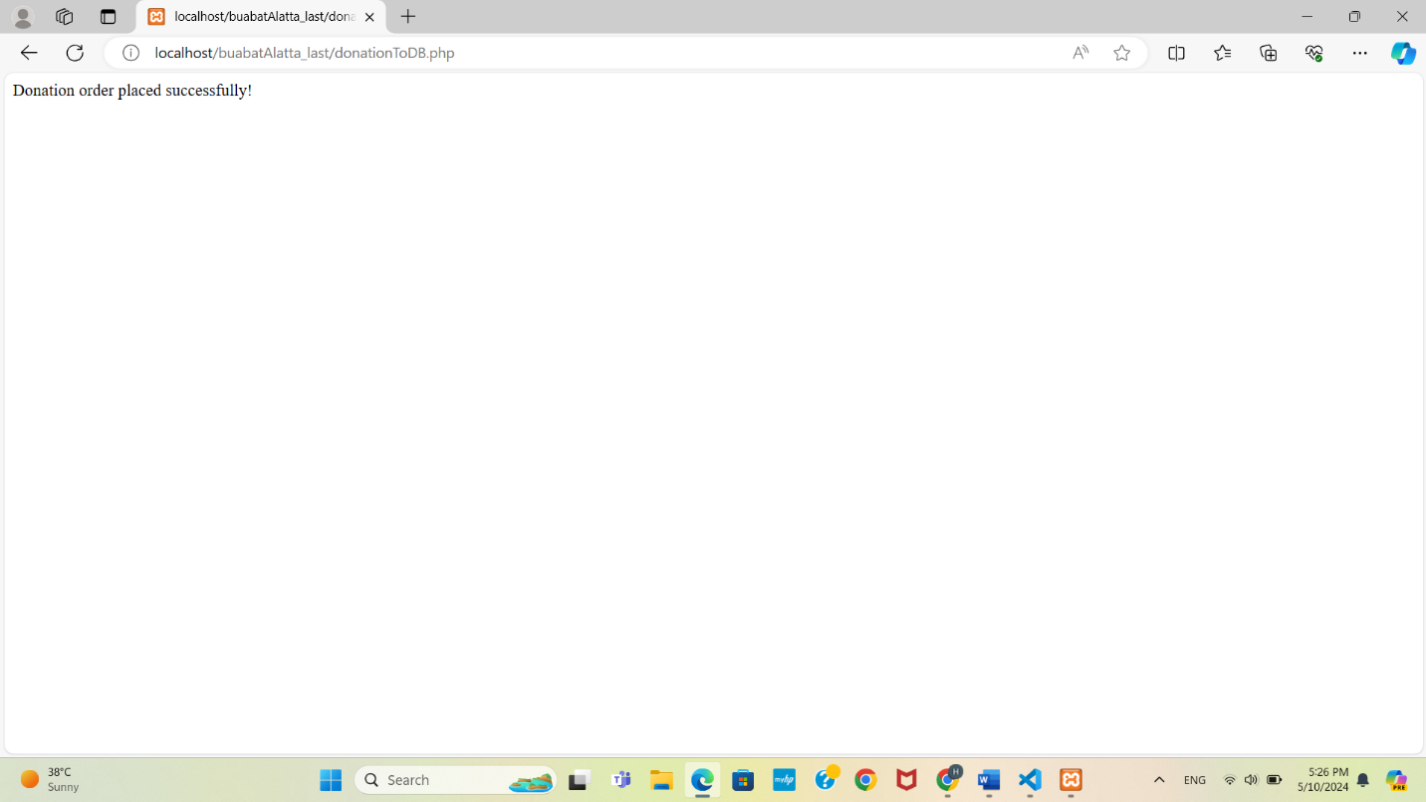

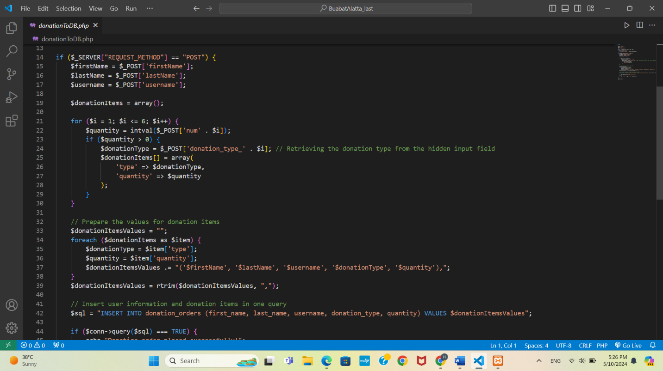

storeToDB.php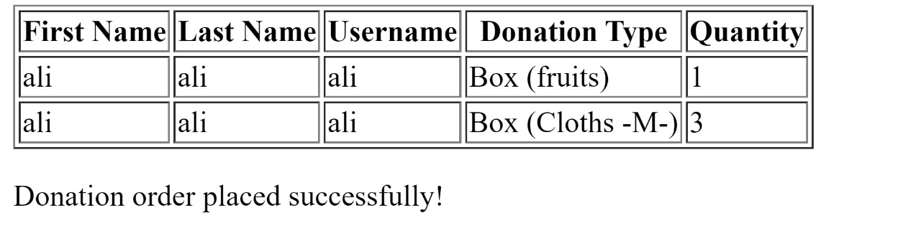

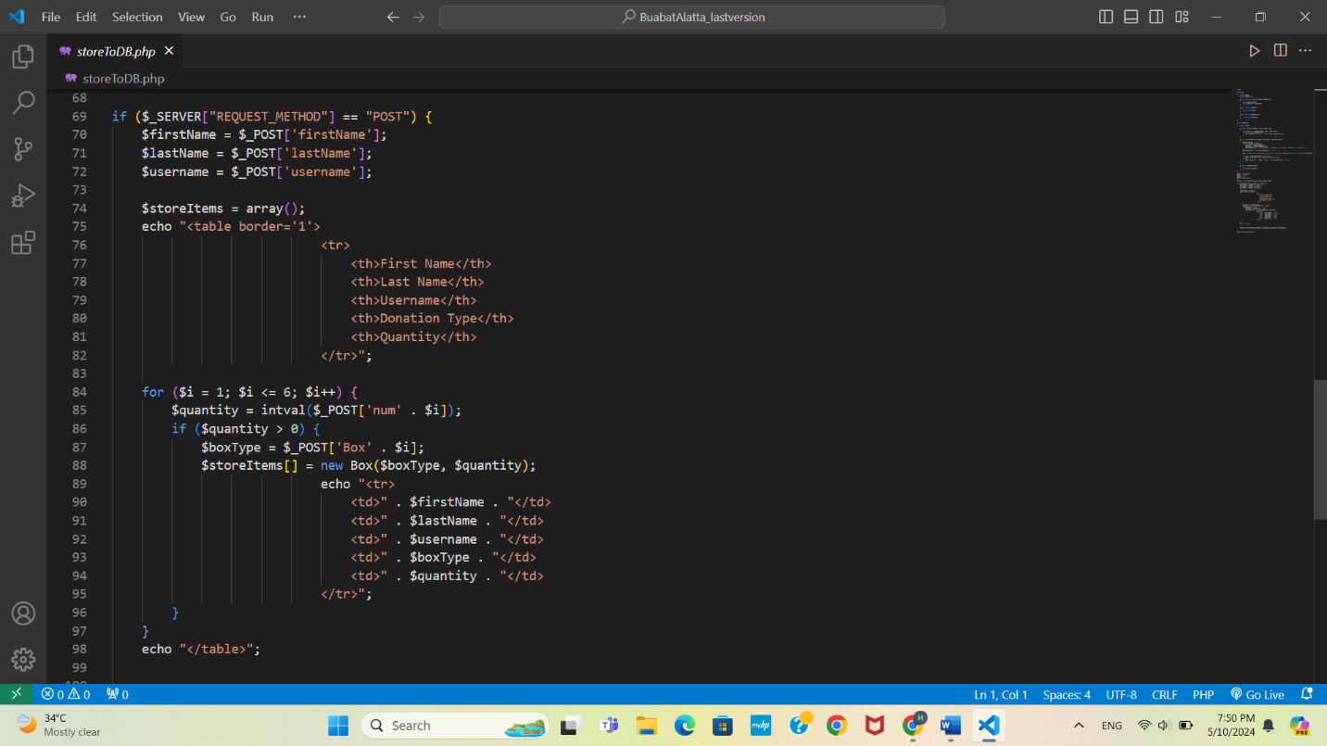

vollenteerDB.php:

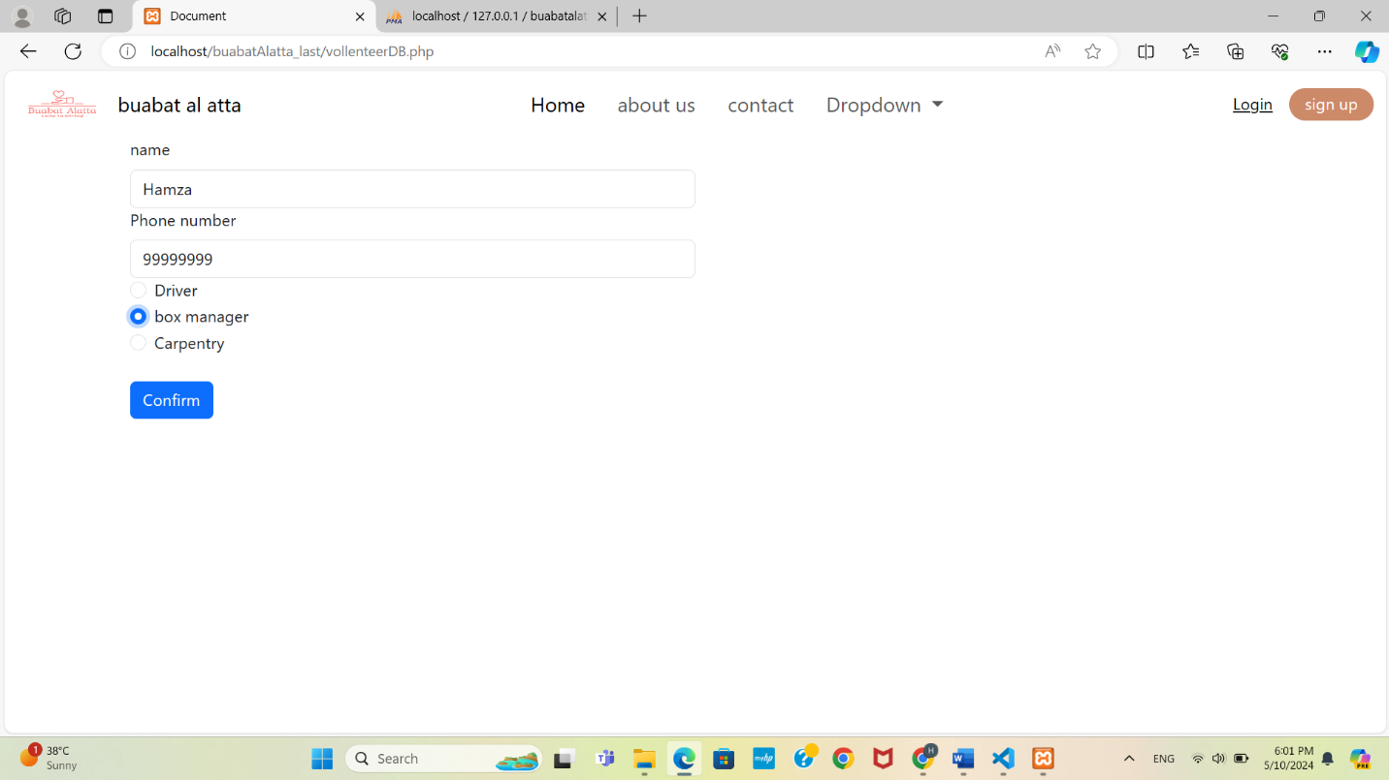

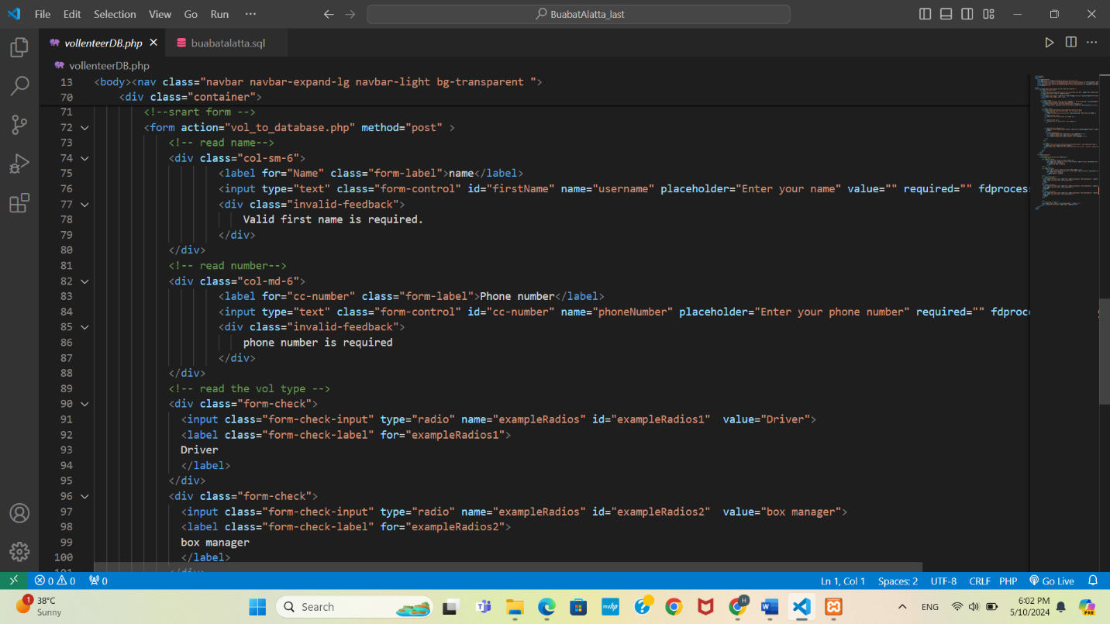

vol_to_database.php

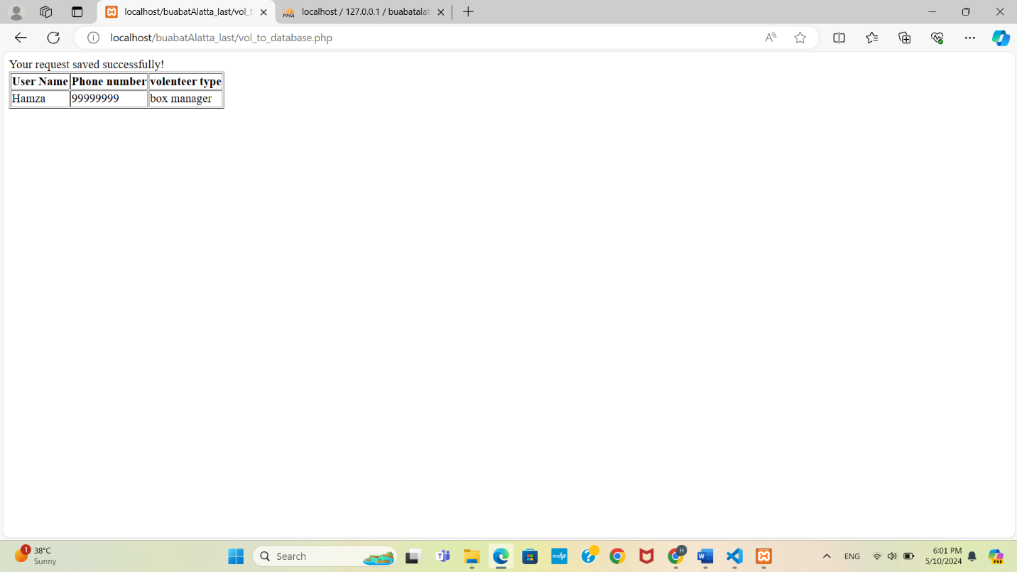

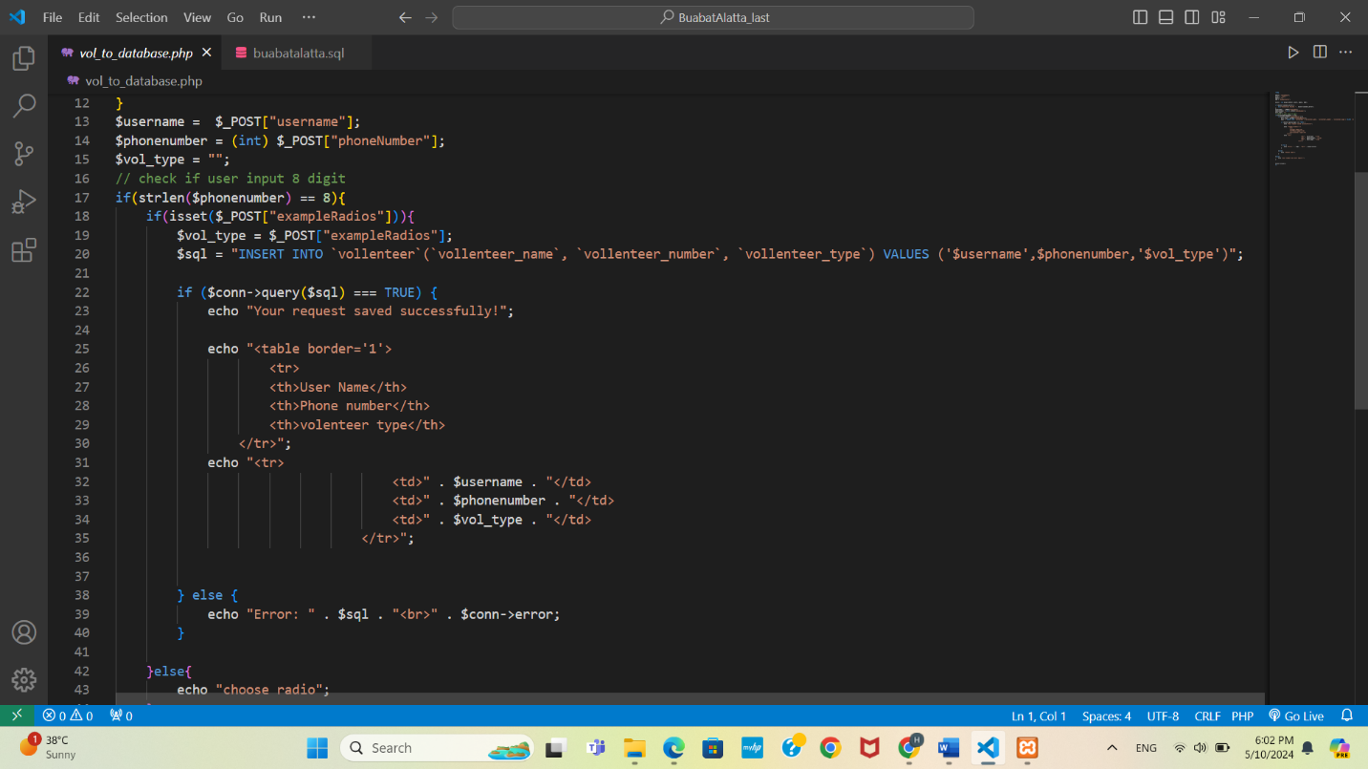

Login_.php

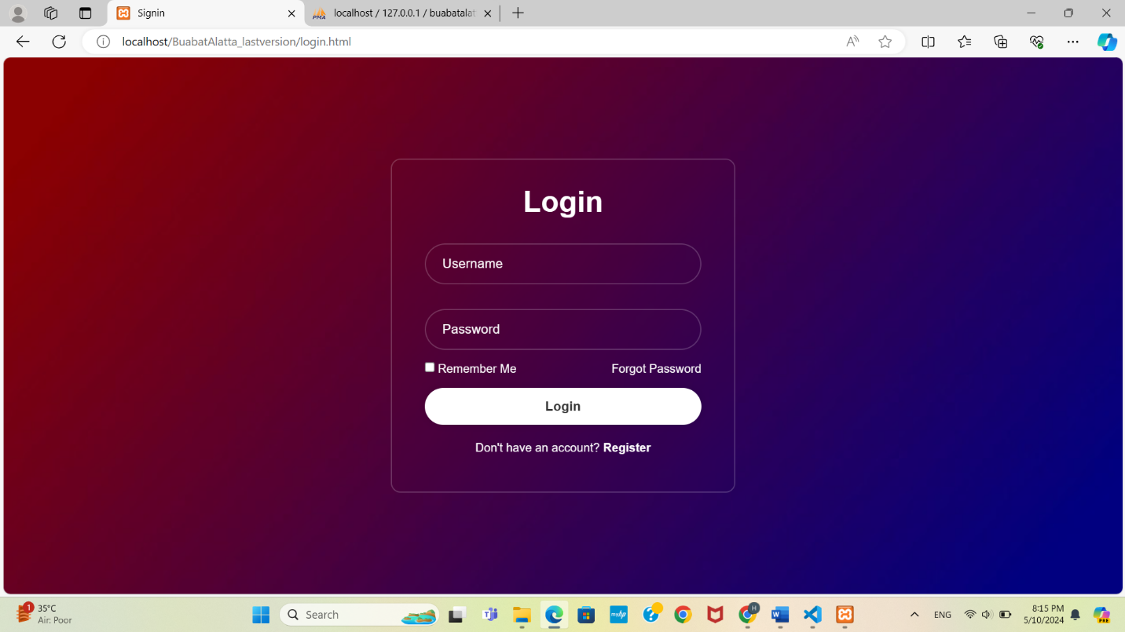

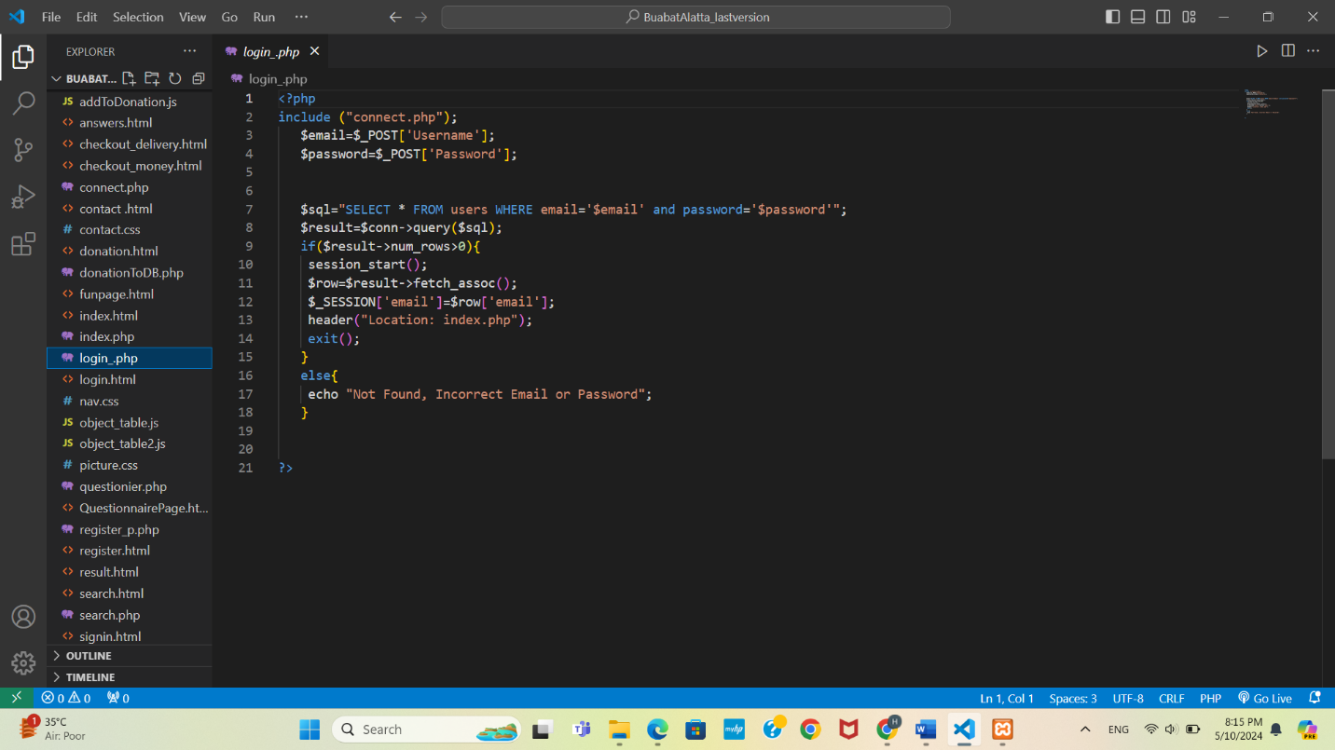

questionier.php

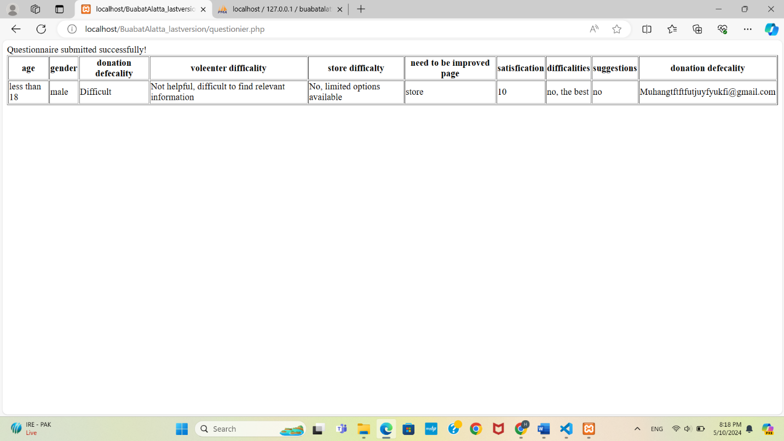

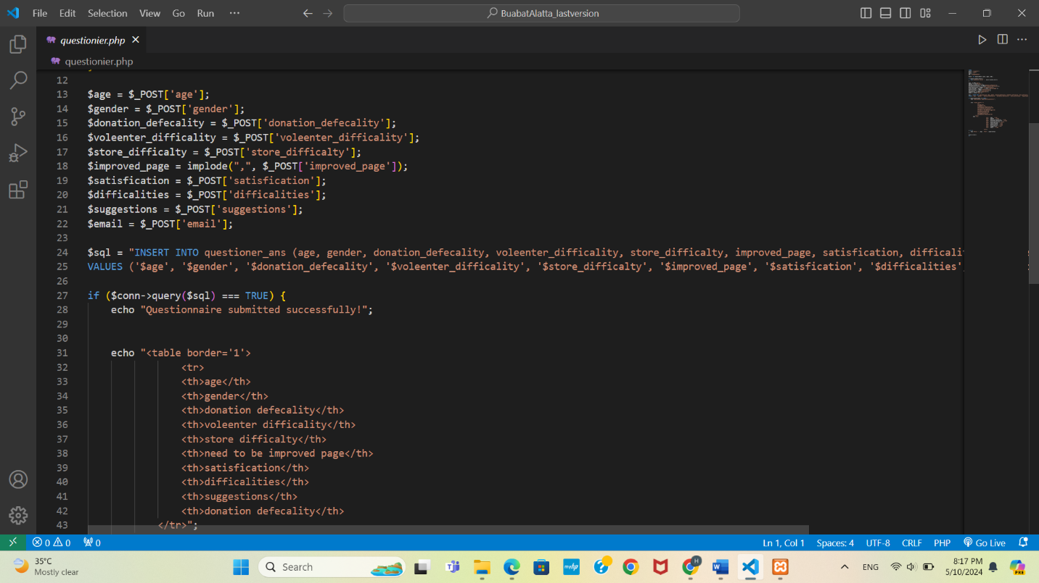

register_p.php:

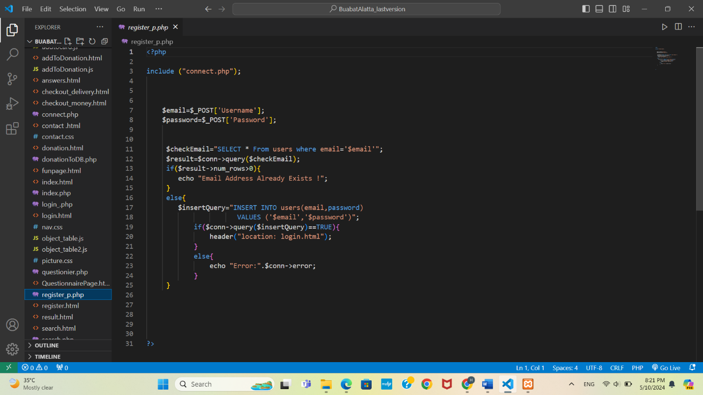

Search.php

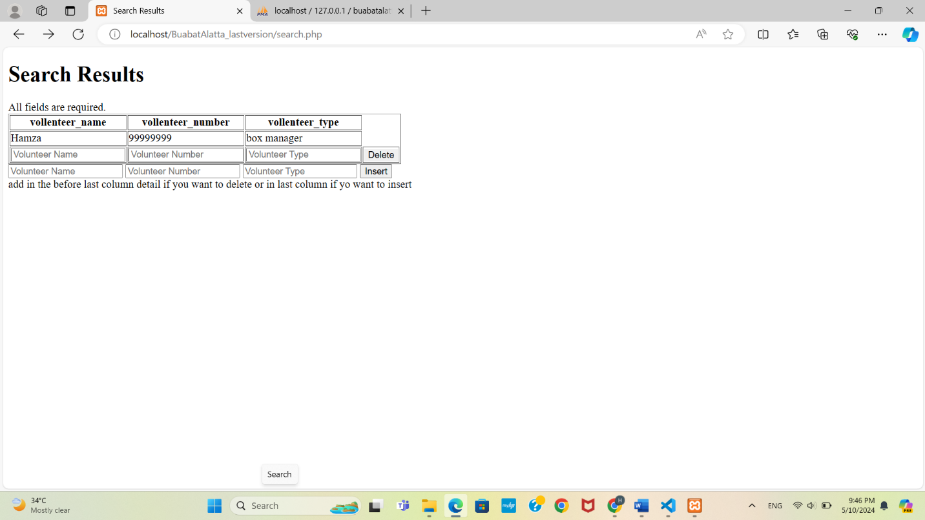

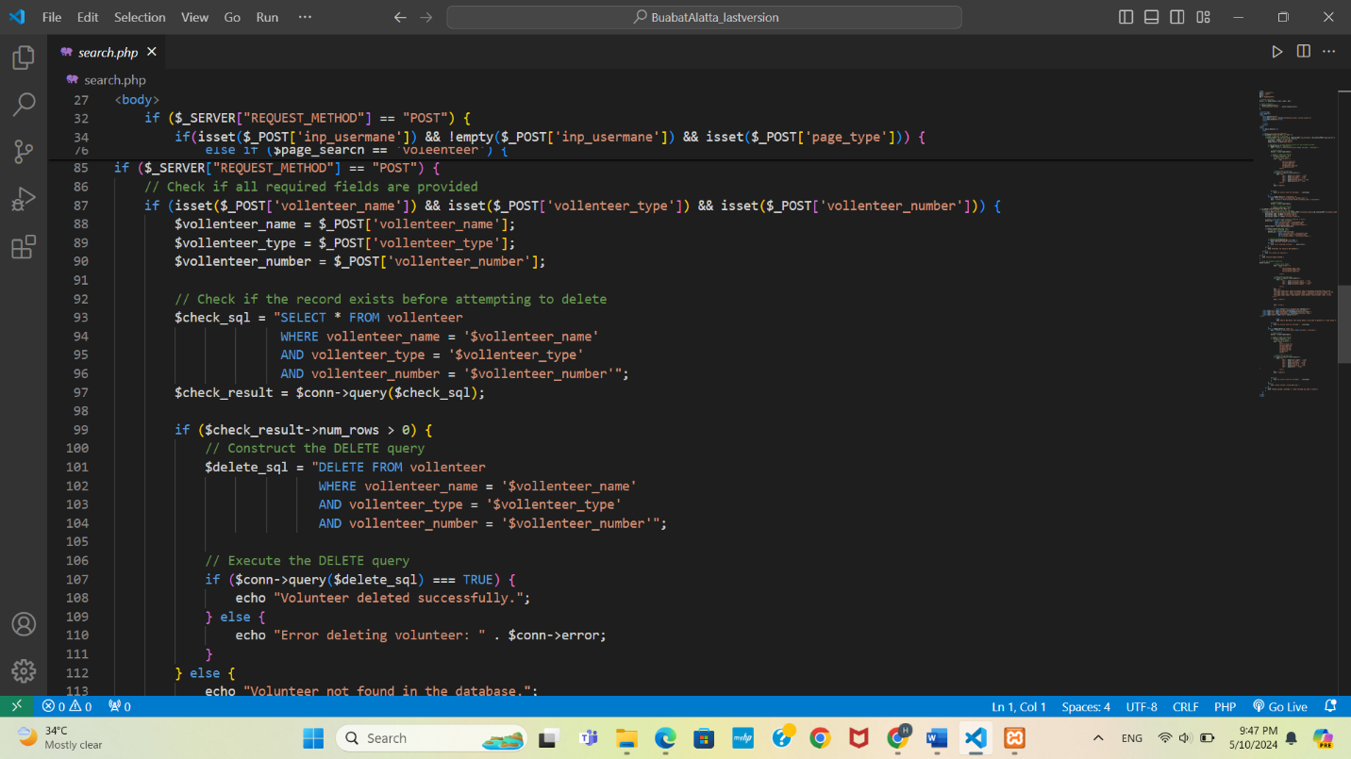

vol_delete.php:

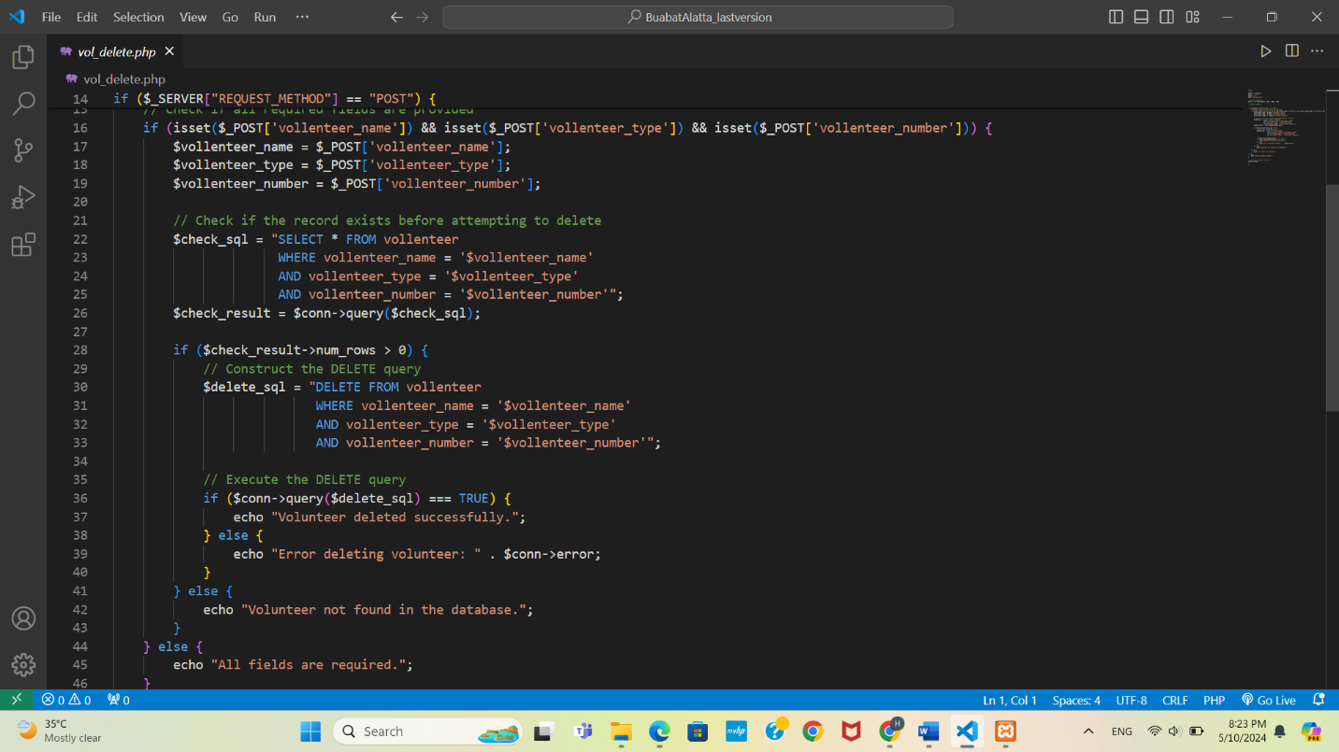

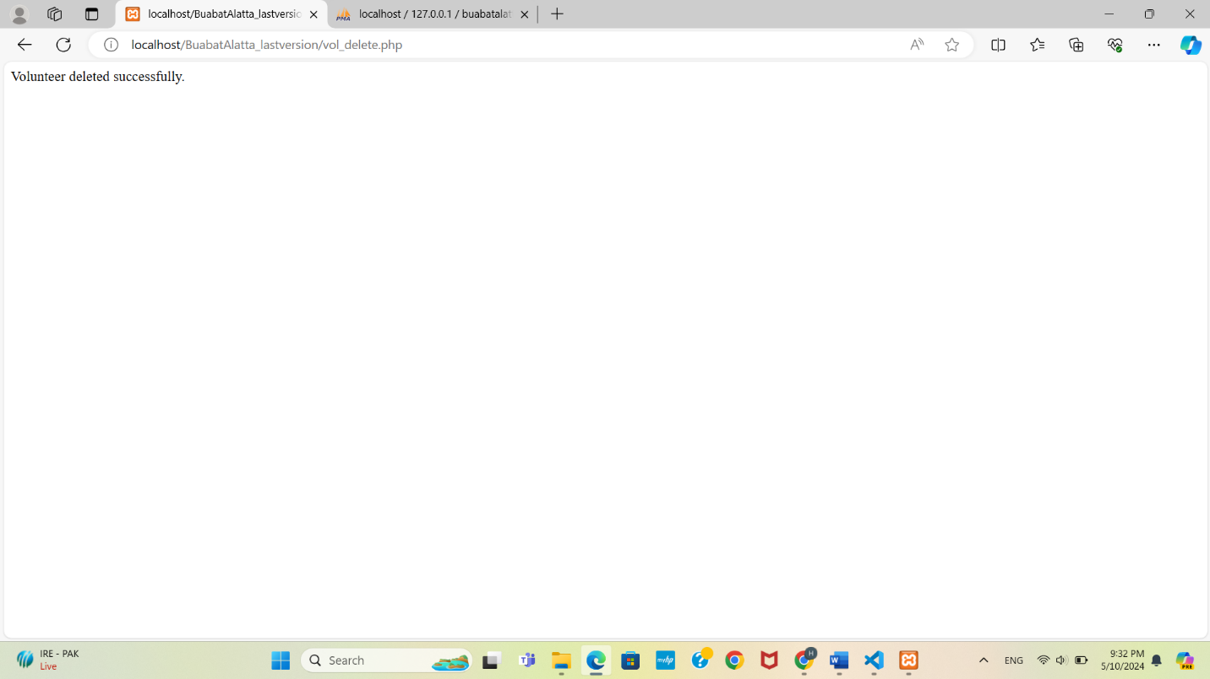

We only make the insertion and deletion for only the vollenteer table; because other table like store and donation is not logical to do deleting and inserting on them.

Data base tables:

Vollenteer table:

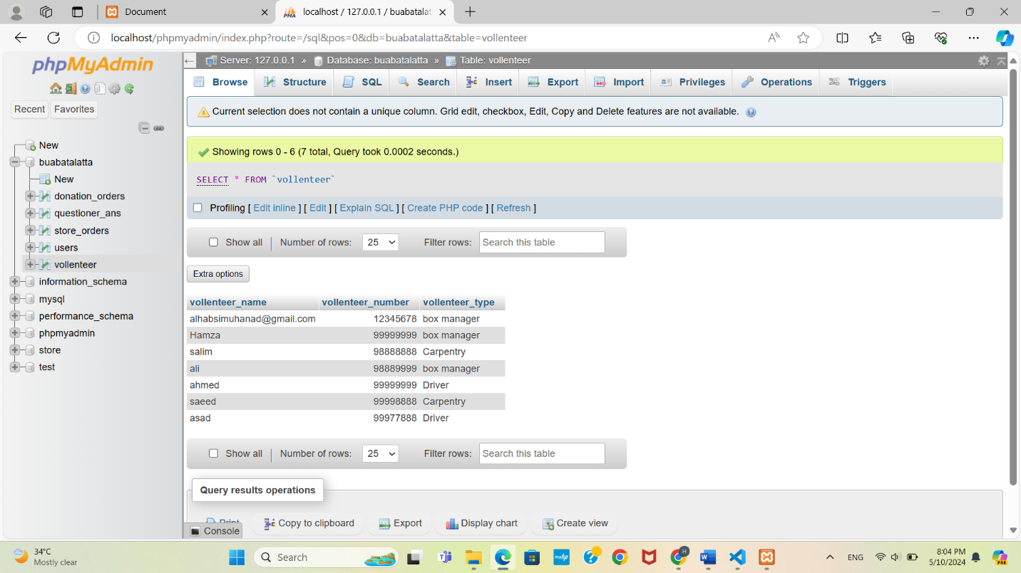

Store orders table:

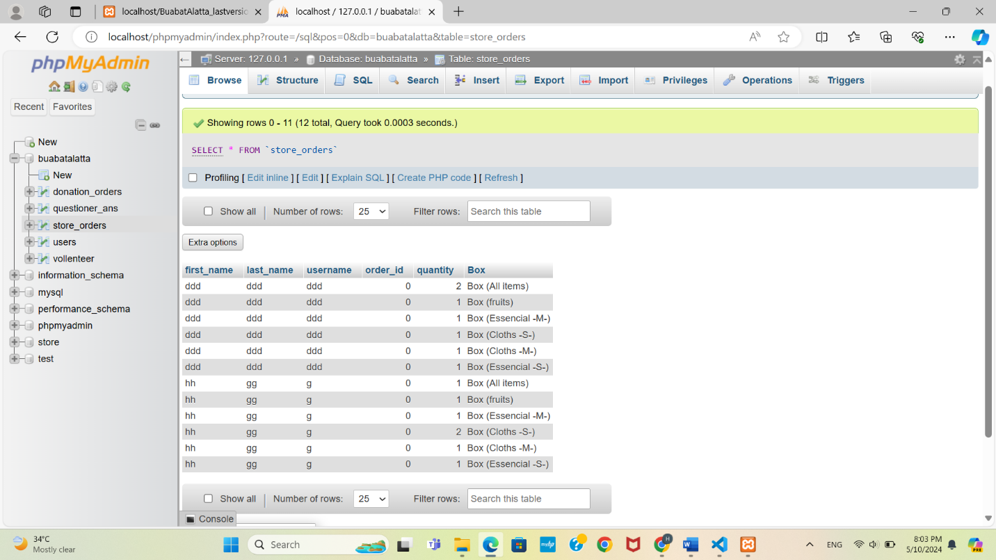

Users table:

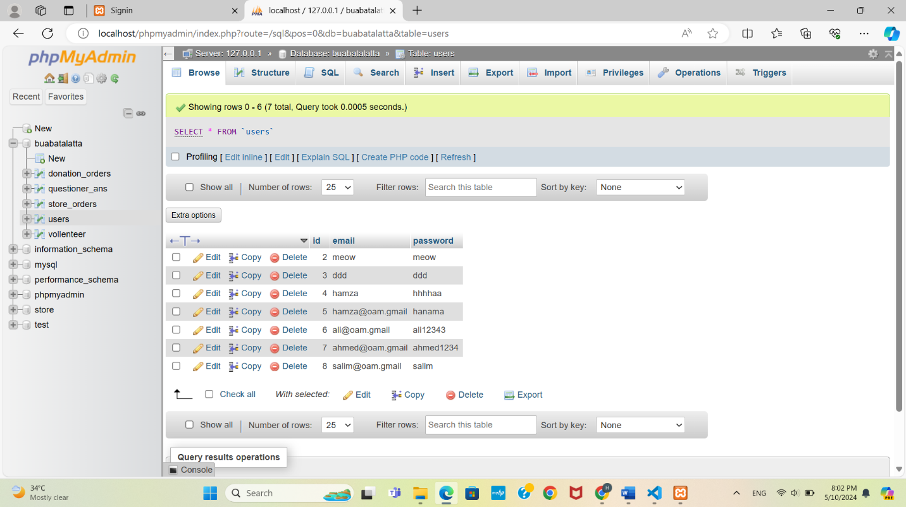

Donation_orders table:

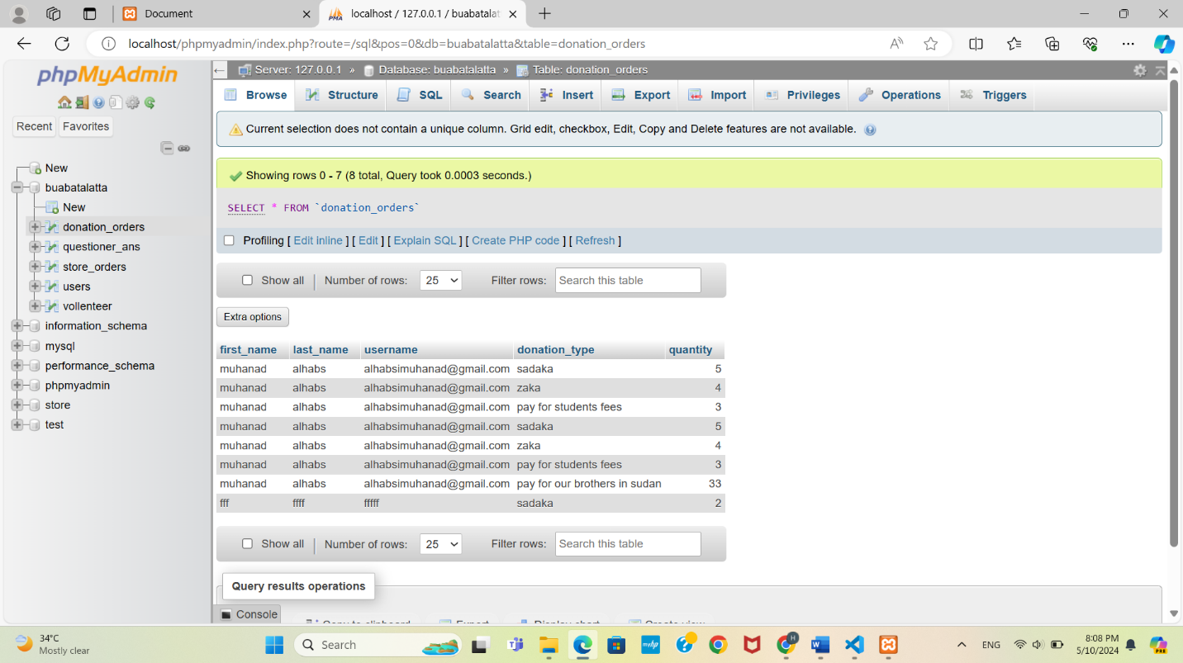

Questioner_ans:

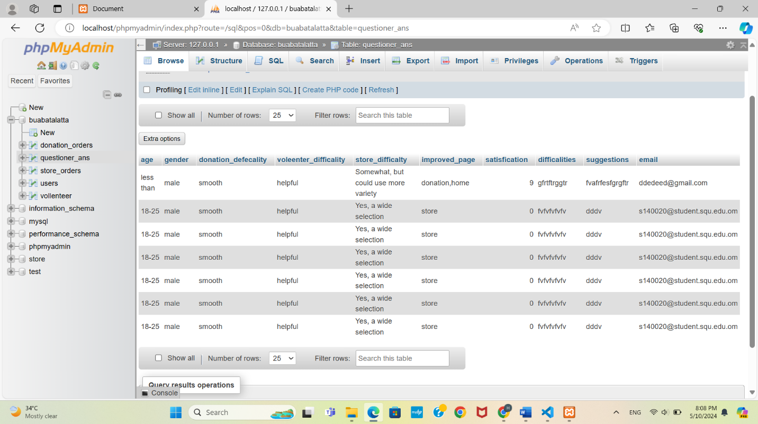

contribution table:

|  |  |  |
| --- | --- | --- |
| Anas | Hamza | Muhanaad |
| Edit addtocard.js | vollenteerDB.php | Questionier.php |
| Edit addToDonation.js | vol_to_database.php | Search.html |
| Edit addToCard.html | Edit volenteer .html | Search.php |
| Edit addToDonation.html | report | Vol_delete.php |
| Edit donation.html |  | Vol_insert.php |
| DonationToDB.php |  |  |
| StoreToDB.php |  |  |
| Host manager |  |  |
|  |  |  |

Github : <https://github.com/A-N-A-S-3000/bawabt-al-ata.git>

Website: <http://buabatalatta.wuaze.com/index.html>

We tried a lot to make the website work correctly, and we tried to fix the problem but still doesn’t work correctly.